**HelpNxt Ticket Tool**

**Web Portal Link**: helpnxt.techmahindra.com/  
  
**Download the Mobile APP:**

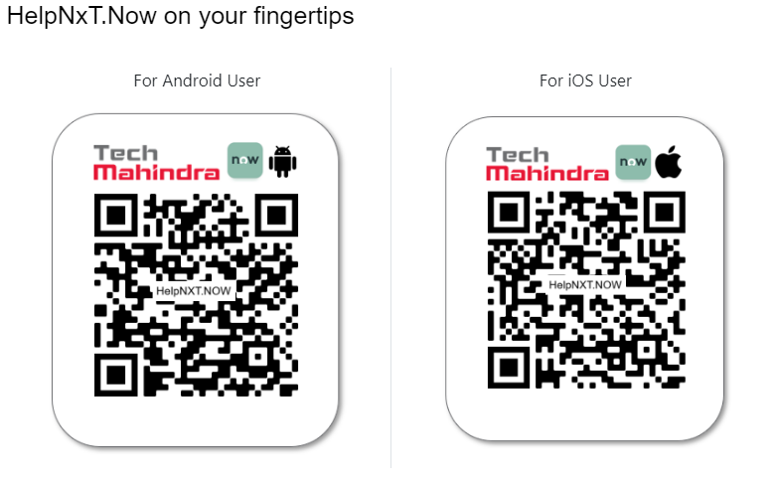

Once you install the App, provide this URL in the Instance Address field, and then proceed with authentication.  
  
  
  
  
  
  
  
  
  
  
  
  
  
  
  
  
  
**Ask HR For Benefits** - Insurance, PF (India), ESIC & COC issues, Claims (ERA), Data Privacy (PI / SPI / GDPR), KUDOs - Rewards & Recognition, Learning systems (LLS, TLS), Mobility ( Business travel & Deputation & Group transfers), New Hire (Joining Bonus, NP Pay, Data correction & Referral), Payroll Issues ( Leave, Timesheet & Salary) and Separations (Resignation, FFS & Exit Related).

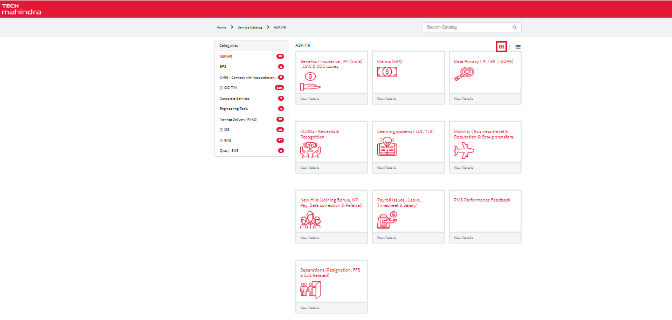

**CIO / TIM** – For Technical requirements and assistance: Our mission is to provide Technical Infrastructure Management Services and IT Applications, which are aligned to meet with the business goals of Tech Mahindra. CIO/TIM's endeavor is to maintain high uptime on our communication & computing services and to provide all services in a proactive, cost effective, well planned, and secure manner. Kindly raise request/issue under appropriate category with CIO/TIM.

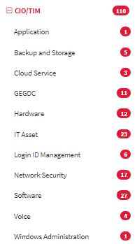

**Corporate Services** - For Admin Services, ARTS IN & OUT Physical Access Readers, Engineering Maintenance.

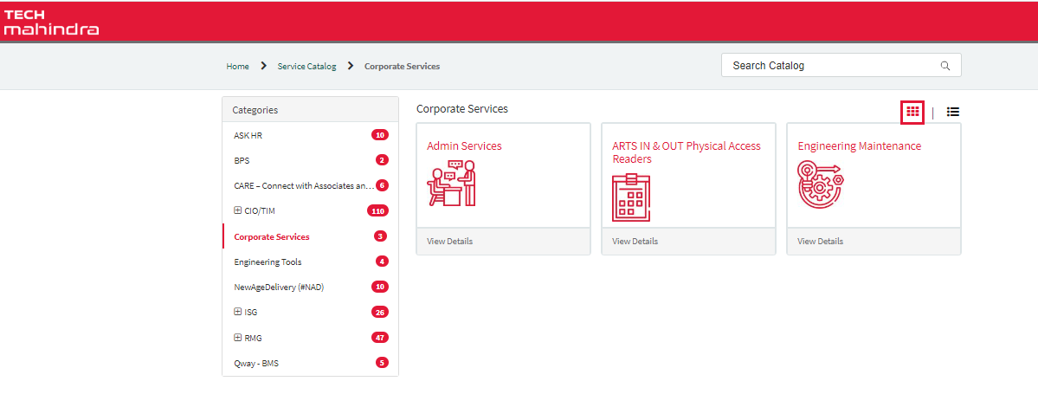

**CARE** – Connect with Associates and Resolve with Engagement: Ethical practices (Code of conduct, Interpersonal issues, Policy Violation, Sexual harassment, Work harassment.

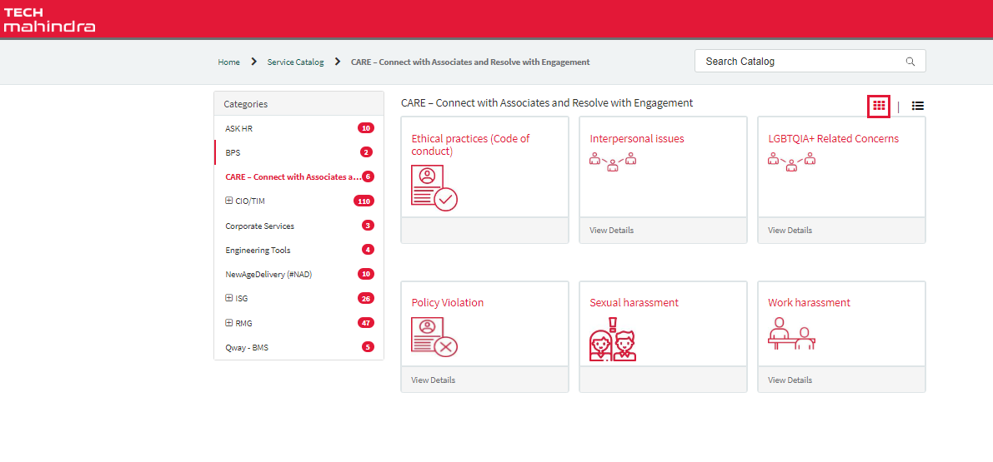 **ISG:**